PokeLeeks

Version 1.3.1





1. Introduction

Welcome to the world of Poképoireau.

Congratulations to you young trainers, you were called by Professor Chen to choose your very first leek. He has decided that you are now ready to begin your quest across the country, and face all the other trainers, in order to obtain the coveted title of "Leek Master". Before you get there, you're going to have to train your little leek, teach him the best fighting techniques and encourage him to help him get stronger and stronger.



Choose well, it will accompany you all your life!

1. Instructions

* Read everything before you start!
* During this project, this  [link](https://leekwars.com/help/tutorial) could be very useful to you.
* The Internet is a great tool to discover how things work, use it regularly!
* If you block, do not hesitate to ask your comrades for help and then a Cobra.

1. One day I will be the best trainer
   1. There is no champion without training

Indeed, we will have to work hard to get to the top and become the strongest! For this, Professor Chen has created an online website so that you can train your little leek remotely.

Start by creating an account at this address: <https://leekwars.com/> . If necessary, you can pass the site in French or English. Sign in with your Github account or email address. If you choose the latter, check your box to validate your account.

LeekWars is a site whose goal is to create your Artificial Intelligence to fight against the AIs of other players. Your goal is to create the most adaptive AI. To do this, different weapons, skills and spells are available.

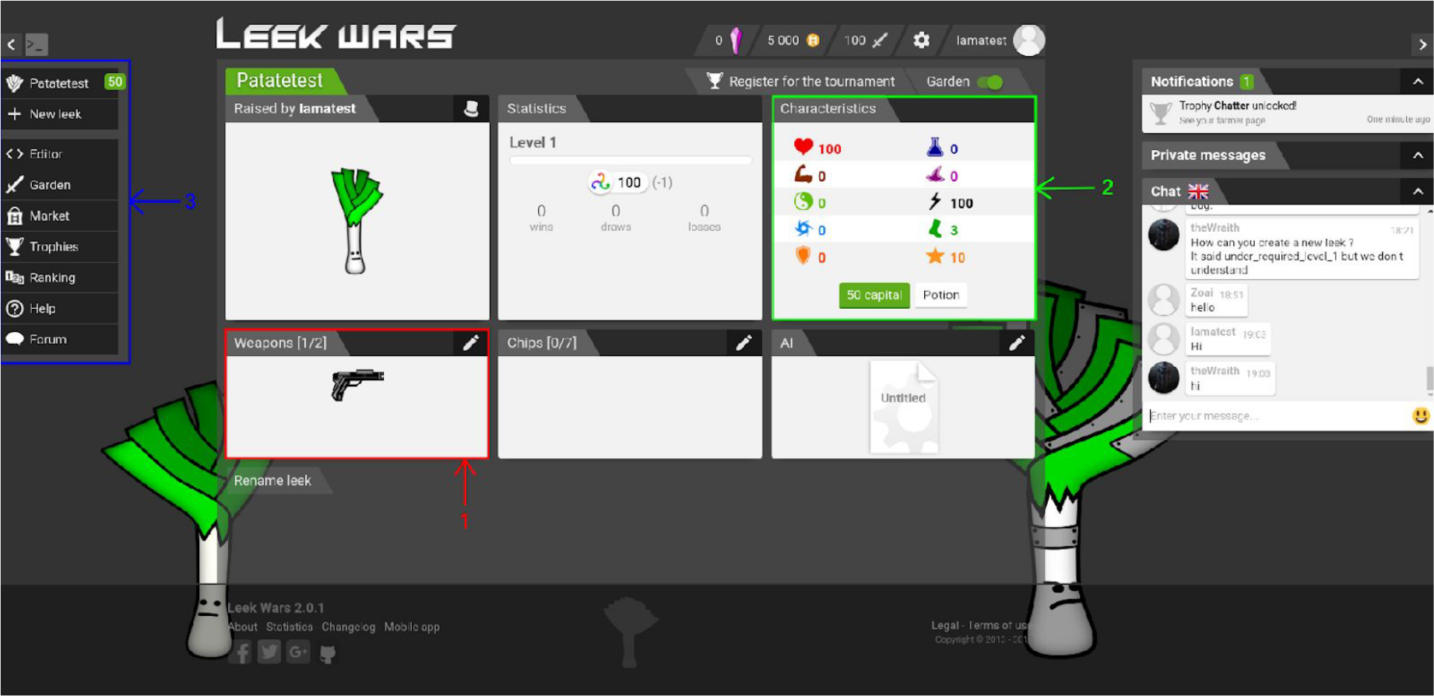

5

4

Here is the profile of your leek, here you can observe the least of its characteristics

In the image above you can see different color blocks accompanied by a number in order to explain the interface a little.

In 1, you have the items equipped, you can see that in the weapons box is the basic gun.

In 2, these are the characteristics, these are your abilities such as your life, your strength, the frequency at which you will have the chance to start the fight, your action points (TP), etc. Don't forget to assign points to these different stats when you pass a level, in order to make your leek perform better.

In 3 is your Menu which contains several possibilities:

* Editor, allows you to modify the AI of your leek.
* Vegetable garden, to fight other leeks.
* Market, in order to buy weapons or spells.
* Team, to access it when you have one.
* Trophy, it is here that you can consult your different objectives achieved.
* Leaderboard, compare yourself to other players in the world!
* Help, to access tutorials and documentation.
* The forum to talk and exchange with the community.

In 4 you can directly consult the active AI on your leek. As you know, a young beginner leek does not really know what to do to win against his opponents, he relies on you to help and guide him in his actions during a match. This is where AI will come in! An AI (Artificial Intelligence) is a program that adapts and responds differently depending on a given case. The most concrete example is the artificial assistant found in all phones such as Google assistant, Siri, Microsoft AI...

In 5 when you have them, you can buy spells!

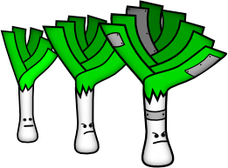

Little leek will become big!

* 1. Start off on the right foot!

Let's start by looking at some programming basics. The first? The variables!

What is a variable?

A variable is used to store a data, a number, a character string or many other types such as comma numbers, etc. You can simply store information in order to modify and reuse it later! If the player moves 4 squares for example, this allows you to first keep the location of your character in a variable, then later, to modify its value. To create a variable in LeekWars, just write it like this:

var position = 1;

Then you add 4 to this variable:

position = position + 4;

Your variable will therefore be worth 5 after this line.

Then, to display text or a variable, you must call a function. A function is a piece of code that is surrounded by braces "{}" and everything inside will be executed when you call it. In Leek Wars, it looks like this:

function moveforword() {

}

This serves several purposes: first, to avoid copying code that does the same thing, but also to make the code more readable or generic.

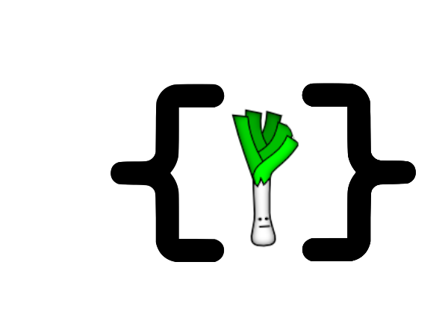

We can say that your leek is a hell of a funny!

1. AI is your greatest strength
   1. It is important to know your student well

Your new leek friend already has some basics in combat, but they are very simple and without your help he unfortunately could not progress.

Go to the editor. You will find a code generated by default. To understand it, you must observe it. Each turn, your leek will execute the code line by line, in the reading direction. Here's what the first line looks like:

Take the pistol

setWeapon(WEAPON_PISTOL); // Warning: cost 1 TP

As written in the comments, which is the line starting with //, this code defines the weapon in hand, here WEAPON_PISTOL. Each action costs TP (shooting points), the number of which varies according to the statistics of your leek. It is therefore useless to equip your weapon at each turn, you will see it later.

// Get the nearest enemy

var enemy = getNearestEnemy();

This line defines a variable called **enemy** that takes the value that **getNearestEnemy()** sends to it. This value corresponds to the identifier of the leek closest to ours. Who in the case in 1v1, is an enemy. Afterwards, you can attack the opponent using his ID.

Move towards him

moveToward(enemy);

Here, your program advances your leek with **moveToward()** towards the previously designated enemy.

You will add your first changes to this code! Create a condition signified by if in order to recover the number of turns passed and take out your weapon only if it is equal to 1:

// Take the pistol

if (getTurn() == 1) {

setWeapon(WEAPON_PISTOL);

}

To test your program, either you can use the test button and create a scenario against Domingo which is a leek of your level, or you can face strangers in vegetable garden.

* 1. Hop, hop, hop it has to move!

How about improving your friend's travel? History that he can react when a specific event happens. Start by changing the way the leek moves to diversify its movements. You can push it back, go left or right when hit by the opponent. Thus, add an action that will allow you to move forward by 2 and back by 1:

// Move towards him

moveToward(enemy, 2);

// Try to soot him  
useWeapon(enemy);

// Move away

moveAwayFrom(enemy, 1);

For example, to deepen, you can move your leek behind an obstacle to protect yourself, or bring the enemy to a closed place to block him.

* 1. By ice!!

You saw at the very beginning that your leek only shoots once per turn and spends three TP. Now try to strike several blows at the enemy with your weapon. For this, you will need to know your TP, this is where the **getTP()** function comes into play. As its name suggests, it recovers the TP of a leek; This makes it possible to analyse the situation and react accordingly.

// Try to shoot him!

var my_tp = getTP();

Now your leek will have a little more compared to the basic AI. And your enemy will only have to taste your shots every turn. However, pay attention to your TP: your weapon uses a certain number, of the order of 3 for the basic weapon, so if you try to shoot but it does not have enough, your AI will loop on this part of the code and therefore end up with timeout, that is to say that the reading of the code will not stop and that the actions planned in consequence will not be carried out.

Information

For loop while, here is the condition proposal.

**my_tp > [ number of TP used by your weapon ]** instead of **my_tp > 0**.

Below you have the example of a code that will work without worries!

// Try to shoot him!

var my_tp = getTP();

var shoot = USE_SUCCESS;

while (my_tp >= 3 and shoot != USE_INVALID_POSITION) {

shoot = useWeapon(enemy);

my_tp = getTP();

}

* 1. Social distancing is key!

To improve your movements, you must be able to take into account the distance between your champion and your opponent. First, recover your position and the enemy's position. To do this, use the **getCell() function**. Enter the following code:

var pos_enemy = getCell(enemy);

var pos_player = getCell();

⚠ Careful

Your location (Cell) does not match your ID!

In order to develop, you can also take into account the distance between you and your enemy. To do this, use the **getCellDistance() function**: This takes two positions as parameters, yours and that of your opponent.

var dist = getCellDistance(pos_player, pos_enemy);

Now that it's done, you can use this new data to take cover, go within firing range, plan your trips to take advantage!

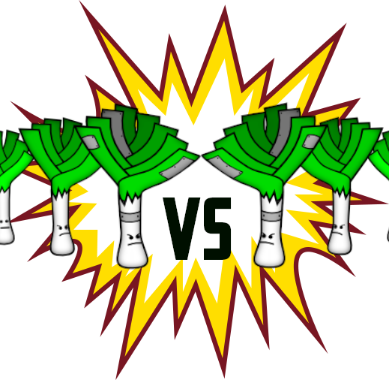

It's time for the dududuel!

1. The incredible powers of leeks:

Great, well done! Your progress is dazzling, and your leek more effective! You have had the opportunity to see the use of weapons, the movements... But have you thought about treating yourself? To use magic to attack your opponent from further away? This is possible thanks to the chips that you can buy in store:

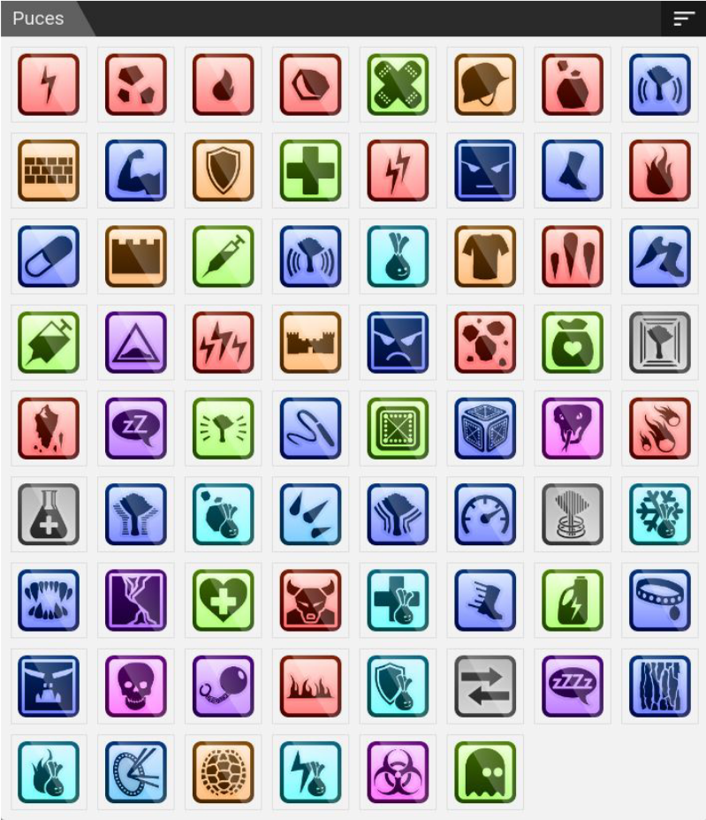

The possibilities are endless, choose your powers wisely!

* 1. Patch up the leek

Your brave companion may suffer damage, you will have to anticipate all this, to optimize your fights. To be able to do this, it is necessary to have reached level 3, so do not hesitate to face your neighbors, or strangers to increase your experience. After that, you can buy the chip CHIP_BANDAGE:

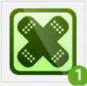  
Indeed, it is a band-aid!

You can now put it on your leek. To do this, go to the main tab of your leek and equip it. Once it's done, code the part to use it. Try to follow the following logic to add it to your AI: if you lack life, then use the care chip.

health

var Life = getTotalLife();

var life_now = getLife();

var my_leek = getEntity();

if (life_now < Life) {

useChip(CHIP_BANDAGE, my_leek);

}

Your vegetable can now be cured! You will be able to resist longer under enemy fire. You can also use protective chips, which will be used to prevent injury.

* 1. Dig up the opponent's leek

Perfect! You start to become a true professional. Now improve your attacks by using spells to give enemies a good beating! To start using ranged attack spells, you need to start by buying one of the offensive chips, which are represented by the color red.

  
This is your fate!

As you can see next to the chip, you have here several information about it such as its range, the TP necessary to use it or the damage it inflicts. For the latter the range is 0 to 6 blocks, 2TP are needed to use it and it does 5 to 7 damage per use.

One of the first uses you will have will be:

Use Chip_Shock

useChip(CHIP_SHOCK, enemy);

Here you are just using the Shock spell on the opponent. Now improve your algorithm to activate the chip if the range of your weapon is less than your distance from the enemy AND the range of your chip is greater than or equal to your distance from the enemy.

* 1. Small tour to the armory

How about moving up a gear? After all your fights, you should be able to buy a new weapon. The MACHINE_GUN is a starting weapon of choice for this new experience. To equip it make as for chips. Now let's see how to use it.

An image containing weapon, firearm

Auto-generated description

Here's the amazing MACHINE_GUN

You already have functions using the weapon. But how can we change it? Use the same principle as for the very first gun you had:

Change our weapon

setWeapon(WEAPON_MACHINE_GUN);

You can now add a condition in order to choose when to take out the weapon and not spend 1 TP on each new turn.

1. Discover the ultimate knowledge manual

You begin to become an expert, Professor Chen has nothing more to teach you. The student has surpassed the master! From now on, you will have to do your own research and experiments to increase your level.

But you're in luck! Documentation is provided by the site. There you will find all the functions that you have not seen yet. There will also be information on how to achieve AI if you want other ideas for your leek. This part is located in the help part of the site. There you will find information about the different functions that exist and that you can use. To do this, you must select the function you want: you will then know what its parameters and feedback are. Have fun!

  
You'll have to read all this to your leek, everyone knows they can't read.

1. Always further, always higher, always stronger!

Your training is coming to an end, you have evolved a lot since you got your leek back. We feel how much you are linked now; you have become inseparable! The teacher would like to congratulate you one last time before you go on crazy adventures.

If you want to go further, he has concocted a small list of things to do:

* Customize your leek!
* Increase your level and improve your powers.
* Create a team with your friends by clicking on your profile to train together!

Good luck to you young leek!

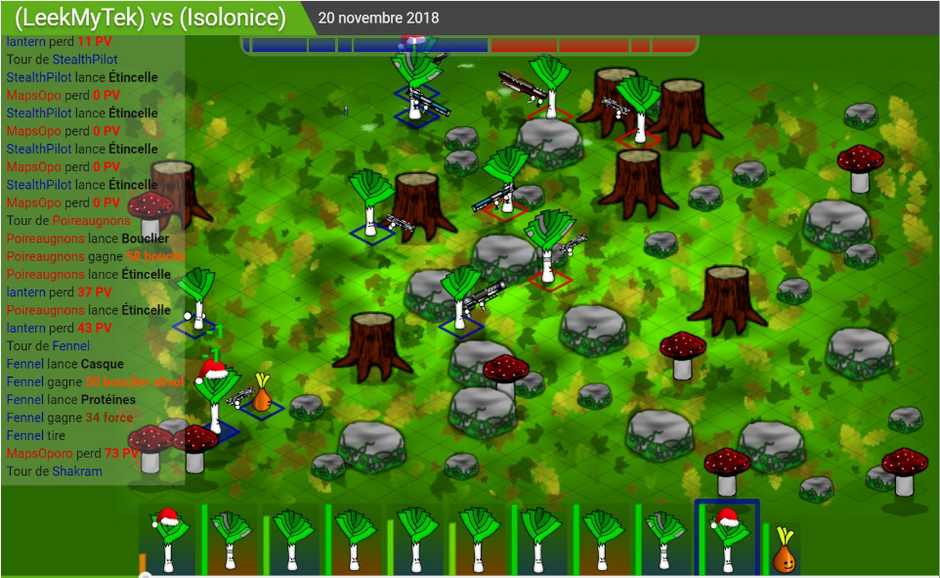  
Build a team with your friends and be the best!